Heavy Press & Die Inquiry Form
This Form is for technical inquiries for Aluminium & Steel sample preparation. Heavy presses, punches, and dies for manufacturing ASTM style samples for metals tensile testing.

For an exact, optimal design of the system and offer, it is important that we are fully informed. Therefore, we ask you to answer the following questions. Please add according to your experience
and delete contents, drawings, questions that are not relevant for your requirements.
- If minimum AND maximum sheet thicknesses are not known, the number of tools cannot be determined.
- Unless we know the sample dimensions (circumference), we cannot recommend an exact punching force
- Should the sample be taken in the direction 0° + 45° + 90° (for R+N value determination deep drawing material)?
Corporate data (end user) |  |  |  |  |  |  |  |  |  |  |  |  |  |  |  |  |  |  |  |  | * „Mandatory field “
* Company name
* Responsible employee last name |  |  |  |  |  |  |  |  |  |  |  |  |  |  | First Name
* Phone office
Phone mobile
* E-Mail
* Street + house number
Building
Region / Province
* ZIP-code |  |  |  |  |  |  |  |  | town |  |  |  |  |  |  |  |  |  |  |  |  |  |  |  |  |  |  |  |  | State (country)
What equipment are you interested in? Punch (press) / several punches |  |  |  |  |  |  |  |  |  |  |  |  |  |  |  |  |  |  |  |  |  |  |  |  |  | yes no
Punching tools |  |  |  |  |  |  |  |  |  |  |  |  |  |  |  |  |  |  |  |  |  |  |  |  |  | yes no
If specimen will not be milled after punching you need Specimen grinding machine |  |  |  |  |  |  |  |  |  |  |  |  |  |  |  |  |  |  |  |  |  |  |  |  |  | yes no
Sensitive material (AL, bake hardening steel) need automatic specimen grinding machine with cooling |  |  |  |  |  |  |  |  |  |  |  |  |  |  |  |  |  |  |  |  |  |  |  |  |  | yes no
Punching line with robot (Several punches, robots, grippers …) |  |  |  |  |  |  |  |  |  |  |  |  |  |  |  |  |  |  |  |  |  |  |  |  |  | yes no
Please select required form (s) and delete dimensions you do not need recommended dimension (LT for example for hydraulic grips) (Minimum according to standard - larger dimensions are allowed)
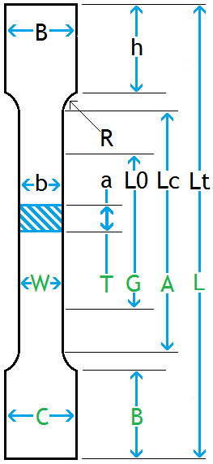 | ISO / EN | ASTM E8 |  | ISO6892  (DIN50125)  A80  mm |  | ISO6892  (DIN50125)  A50  mm |  | ASTM E8  "1/2 (50)  mm |  |  |  |  | ASTM E8  Subsize 6  mm |  |  |  |  |  | JIS  Z2201  mm |  |  |  |  | GHOST 1497  – 84 Type II  mm |  |  |  |  | Your individual / deviating dimensions
 | Lt | L |  | 250 |  | 250 (165 mm) |  | 250 (200) |  |  |  |  | 130 (100 mm) |  |  |  |  |  | 200 |  |  |  |  | 270
 | B | C |  | 30 |  | 20 |  | 20 |  |  |  |  | 10 |  |  |  |  |  | 35
 | h | B |  | 50 |  | ~ 50 (35mm) |  | 50 |  |  |  |  | 30 |  |  |  |  |  | 55 |  |  |  |  | 45
 | R | R |  | 20 |  | 20 |  | 20 (12,5 mm) |  |  |  |  | 15 (6 mm) |  |  |  |  |  | 25 |  |  |  |  | 20
 | Lc | A |  | 120 |  | 75 |  | 75 (57 mm) |  |  |  |  | 36 (32 mm) |  |  |  |  |  | 60 |  |  |  |  | 180
 | Lo | G |  | 80 |  | 50 |  | 50 |  |  |  |  | 25 |  |  |  |  |  | 50 |  |  |  |  | 100
 | b | W |  | 20 |  | 12.5 |  | 12.5 |  |  |  |  | 6 |  |  |  |  |  | 25 |  |  |  |  | 20
 | b+ | W+ |  | Oversize 10 - 15 % of max. sheet thickness per side (removal of edge damage)
 | a | T |  | Sheet thicknesses – possible 0.05 – 12.0 mm |  |  |  |  |  |  |  |  |  | mm:  (min.: 0.05) |  |  |  |  |  |  |  |  |  |  | mm:  (max.: 8.0)
Note: The max. sheet thickness of 12 mm cannot be increased as the edge damage increases accordingly (10% of the sheet thickness) and can no longer be removed with the specimen grinder (even with active cooling). The thickness to width ratio should not fall below 1:1.5.
In the punching technique, for example, a material with a sample width of 12.5 mm cannot be punched at a thickness of 12.5 mm.
Depending on your needs and conditions we also can offer to implement into the tool also one or two additional samples (or different tools). Please select (or delete this rows)
Other sample forms |  |  |  |  |  |  |  |  |  | Please delete samples / drawings that are not required
Parallel stripes (for bending tests or other)
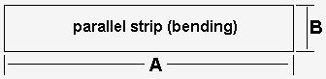 |  |  |  |  |  |  |  |  |  | A (mm): |  |  |  |  |  | 00.0 |  |  |  | Yes / no / comment / (delete?)
 |  |  |  |  |  |  |  |  |  | B (mm): |  |  |  |  |  | 00.0
Circular blanks (for coating testing)
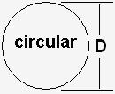 |  |  |  |  |  |  |  |  |  | D (mm): |  |  |  |  |  | 00.0 |  |  |  | Yes / no / comment / (delete?)
Square (for roughness tests etc.)
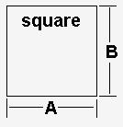 |  |  |  |  |  |  |  |  |  | A (mm): |  |  |  |  |  | 00.0 |  |  |  | Yes / no / comment / (delete?)
 |  |  |  |  |  |  |  |  |  | B (mm): |  |  |  |  |  | 00.0
Sample panels and pre-material (mm) important info
Note: Only state actual, realistic requirements. Insofar as extremely rare thicknesses / rarely high tensile strengths are named (2 samples per year) the forces / costs "explode".
Punching is based on the principle that the punch is much harder than the material to be punched. Punches and cutting plates (dies) are <60 - 62 HRC hard (~ 2,260 - 2,335 MPa). The service life of the cutting punch and die sharpness decreases significantly the harder the sheets to be punched are. A tool can be sharpened approx. 20 to 30 times (provided no damage occurs).
Assumed, not guaranteed punching until sharpening (per tool). A mix of strengths increases / decreases the tool life.
<200 MPa: | 20.000 - 50.000 |  |  |  | <500 MPa: |  |  |  |  |  | 15.000 – 30.000 |  |  |  |  |  |  | <1.000 MPa: |  |  |  |  |  |  |  |  | 10.000 – 20.000
<1.200 MPa: | 5.000 - 15.000 |  |  |  | <1.500 MPa: |  |  |  |  |  | 1.500 – 3.000 |  |  |  |  |  |  | <1.800 MPa: |  |  |  |  |  |  |  |  | 200 – 1.500
From a tensile strength of 1200 MPa, extremely alloyed punching steel VANADIS + SLEIPNER should be used.
From a tensile strength of 1,400 MPa, a hard coating of the active part is strongly recommended (TIN).
Attention: Extremely hard, intermetallic AlSi layers (450 - 1100 HV / 1455 - 3550 MPa), which result from press hardening of Al coatings, must be removed before punching!

Punching force calculation: Circumference mm x thickness mm x tensile strength MPa (Rm) x shear factor 0.8 x shear angle (divide 1000 = kN)
Typically, thin sheets can be very hard due to rolling process (work hardening by cold rolling) and thick sheets are relatively soft (hot strip).
It is therefore NOT reasonable to say: Sheet thickness 0.5 - 8.0 mm, tensile strength 300 - 1200 MPa.
Then we have to calculate: 8.0 mm x 1200 MPa = extremely high punching force. It is much more likely that the 8.0 mm material only has a tensile strength of 700 MPa. This reduces the required punching force extremely. Please look at the tables and find the required punching force for your material and the required punch based on the color sample. Please also give us the answers below this diagram.

Note: The table assumes a sample length of 250 mm (ISO6892 20 x80), smaller or longer lengths will affect the force accordingly.
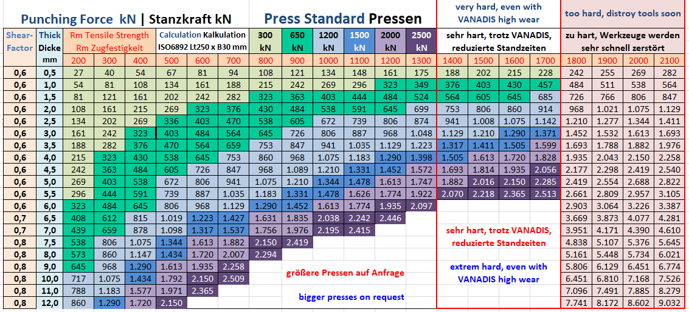
biggest sheet thickness |  | mm
Highest tensile strength at this biggest sheet thickness |  | MPa (N/mm²)
thinnest sheet |  | mm
Lowest tensile strength at thinnest sheet |  | MPa (N/mm²)
General: Max. tensile strength (hardest material) of all sheets |  | MPa (N/mm²)
General: Thickness at this max. tensile strength |  | mm

Size of the starting material (sheets from strip / coil)
 | smallest |  | largest
Size of the sample plate Length (in rolling direction) |  |  |  |  |  |  | mm
Width (transverse to rolling direction) |  |  |  |  |  |  | mm
The sample should not be taken at the edge, but away from the edge of the plate |  |  |  |  |  |  | mm
Direction of sampling 0° lengthwise to rolling direction | Yes / no / comment / (delete?)
Direction of sampling 45° diagonal to rolling direction | Yes / no / comment / (delete?)
Direction of sampling 90° traversal rolling direction | Yes / no / comment / (delete?)
Material grades (groups, no grades such as DC01, St370...) Please delete groups that do not occur
Carbon steel
Stainless steels V2A / V4A, INOX, NIROSTA
Aluminium
Zinc
Copper
Coatings: Zinc, lacquer
Hard coatings (layers) made of AlSi | FeAlSi ... (Fe-Al-Si phases)
Lowest / Highest elongation approx. |  | % |  |  |  | %
Number of samples
Number of samples per shift
Shifts per day
The edge damage resulting from punching is to be removed. Please offer PSM 2000 |  |  | Yes / no / comment / (delete?)
Hint:
When specifying sample thicknesses and strengths, please bear in mind that samples that occur VERY RARELY should possibly not be taken into account. If ALL sample thicknesses and strengths are taken into account, this can strongly influence the equipment and thus the investment sum...
Such special samples can / should possibly be tested externally:
If, for example, a sample 8 mm thick only has to be tested once a year, it can be better milled...

ONCE COMPLETED PLEASE SEND THIS FORM TO CHRISTHOMAS@UNIVERSALGRIPCO.COM

PARTIAL COMPLETIONS ARE ACCEPTED. WE WILL CONTACT YOU FOR FREE ENGINEERING CONSULTATION

